Cause and Effect Diagram Template 2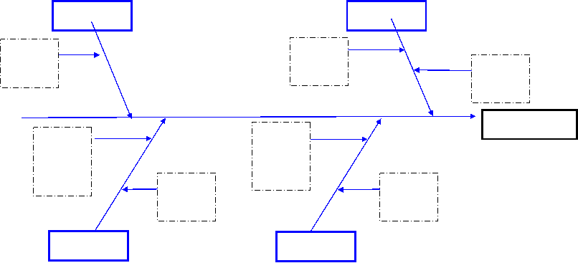Extracted from MDP271a: Project Quality Management

