Cause and Effect Diagram Template 1
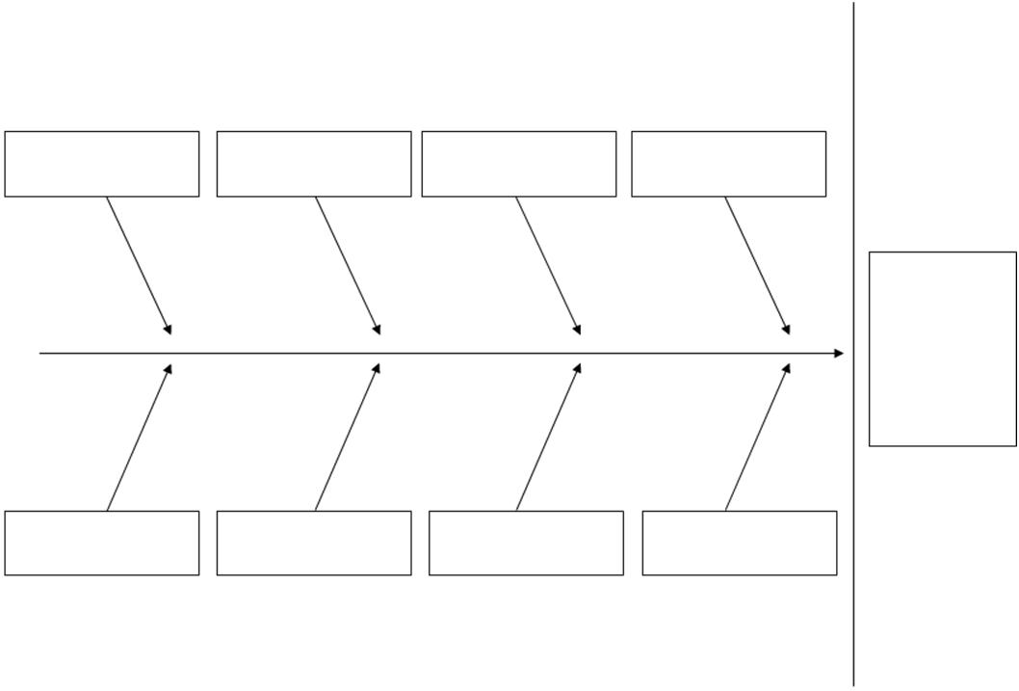

Extracted from MDP273a: Project Risk Management

